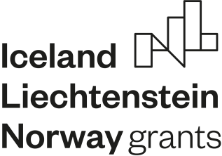
PROGRAMME
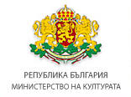
___________________________________________________________
„CULTURAL ENTREPRENEURSHIP, HERITAGE
AND COOPERATION“

INDICATIVE TIMETABLE
FOR THE OPEN PROCEDURES UNDER THE “CULTURAL ENTREPRENEURSHIP, HERITAGE AND COOPERATION” PROGRAMME

- Publication of First call for project proposals under OUTCOME 1 “CULTURAL HERITAGE MANAGEMENT ENHANCED”, OUTPUT 1.2 “CULTURAL HERITAGE OBJECTS MADE DIGITALLY ACCESSIBLE” – March 2021.
- Publication of Second call for project proposals under OUTCOME 2 “ACCESS TO ARTS AND CULTURE IMPROVED” – April 2021.
- Publication of First call for project proposals under OUTCOME 1 “CULTURAL HERITAGE MANAGEMENT ENHANCED”, OUTPUT 1.1 “CULTURAL HERITAGE PRESENTED IN REVITALIZED, RESTORED AND RENOVATED SPACES” – April 2021.
- Publication of the Call for project proposals under OUTCOME 3 “AWARENESS OF ARTS AND CULTURE OF ETHNIC AND CULTURAL MINORITIES IMPROVED (ROMA FOCUS)” – May 2021.

